Day 10 - 29th July 2026

Task 1:
What is spring data JPA?
JPA (Java Persistence API) is a Java specification used to store, retrieve, update, and manage data in relational databases using Java objects.
CREATE TABLE employee (
id BIGINT PRIMARY KEY,
name VARCHAR(100),
salary DECIMAL(10,2)
);

import jakarta.persistence.*;
@Entity
@Table(name = "employee")
public class Employee {
@Id
private Long id;
private String name;
private Double salary;
// Getters and Setters
}

@Entity → Marks the class as a database entity.
@Table → Maps the class to a table.
@Id → Marks the primary key.
<dependency>
<groupId>org.springframework.boot</groupId>
<artifactId>spring-boot-starter-data-jpa</artifactId>
</dependency>

@Repository
public interface EmployeeRepository
extends JpaRepository<Employee, Long> {
}
employeeRepository.save(emp);
employeeRepository.findById(1L);
employeeRepository.findAll();
employeeRepository.deleteById(1L);
Task 2:
What are the key features of Spring data JPA?
Spring Data JPA is a Spring framework module that simplifies database access by providing
- repository abstraction,
- automatic CRUD operations,
- query generation from method names,
- custom queries,
- pagination,
- sorting,
- transaction management,
- auditing, and seamless integration with JPA providers like Hibernate.
- It significantly reduces boilerplate code required for database interactions.

Task 3:
What are core components of Spring data JPA?
The core components of Spring Data JPA are
- Entity,
- Repository,
- JpaRepository,
- EntityManager,
- Persistence Context,
- Query Methods,
- @Query Annotation,
- Transaction Management,
- JPA Provider (Hibernate), and DataSource.
Together, these components provide object-relational mapping (ORM), automatic CRUD operations, query generation, transaction handling, and seamless database interaction in Spring Boot applications.

Task 4:
Now create a spring application using initializer
Create a customer entity with id and account type
10.23 to 10.26

package com.jpa.employee.entity;
import jakarta.persistence.*;
@Entity
@Table(name = "employees")
public class Employee {
@Id
@GeneratedValue(strategy = GenerationType.IDENTITY)
private Long id;
private String name;
private String department;
private Double salary;
public Employee() {
}
public Employee(Long id, String name,
String department, Double salary) {
this.id = id;
this.name = name;
this.department = department;
this.salary = salary;
}
public Long getId() {
return id;
}
public void setId(Long id) {
this.id = id;
}
public String getName() {
return name;
}
public void setName(String name) {
this.name = name;
}
public String getDepartment() {
return department;
}
public void setDepartment(String department) {
this.department = department;
}
public Double getSalary() {
return salary;
}
public void setSalary(Double salary) {
this.salary = salary;
}
}

Task 5:
Add this interface to your above code
package com.example.demo;

import org.springframework.data.jpa.repository.JpaRepository;

public interface CustomerRepository extends JpaRepository<Customer, Long> {
}

In the same project can you create CustomerController.java file..

package com.jpa.employee.repository;
import com.jpa.employee.entity.Employee;
import org.springframework.data.jpa.repository.JpaRepository;
public interface EmployeeRepository
extends JpaRepository<Employee, Long> {
}

Now Test with Postman or curl:

POST → http://localhost:8080/customers
And also check
Check H2 console:
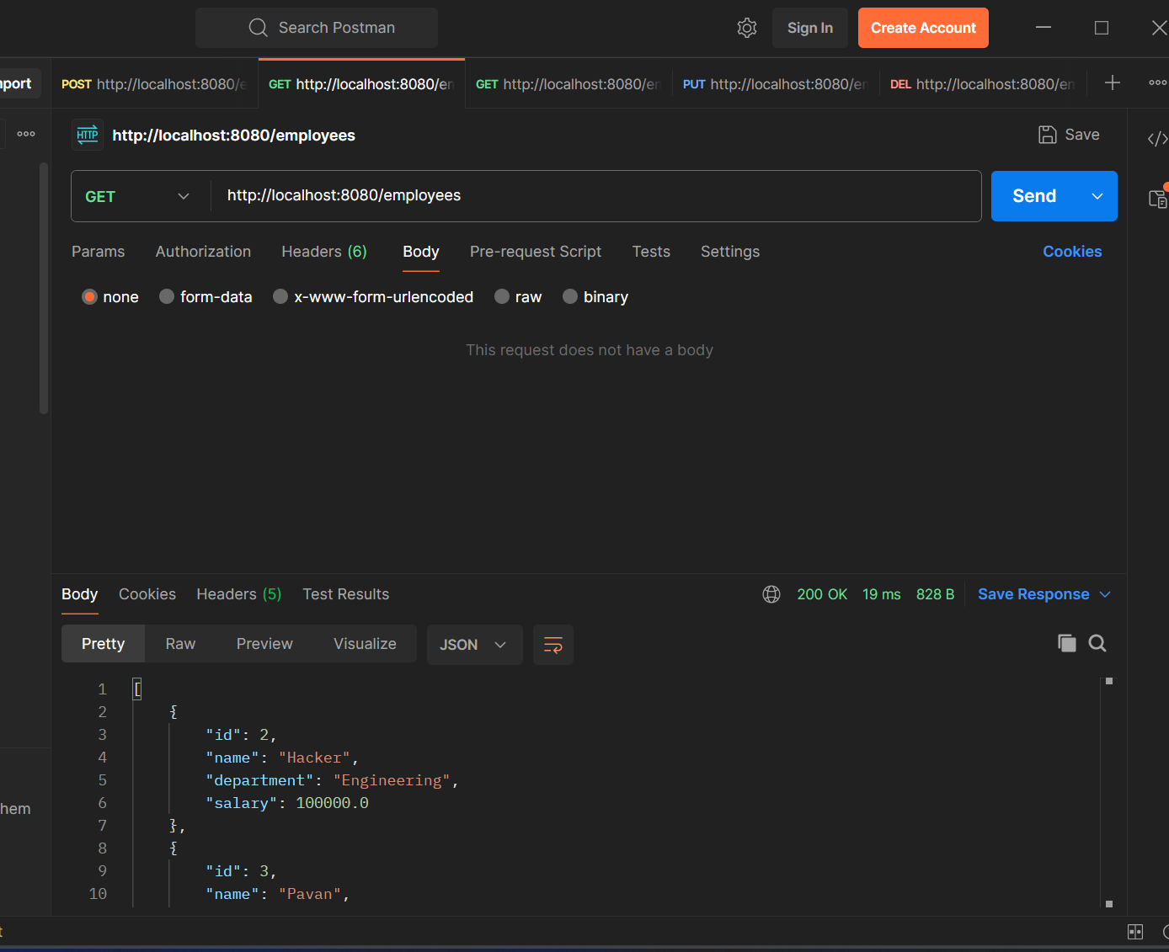

URL: http://localhost:8080/h2-console
Observe the code and its working..

<dependency>
<groupId>org.springframework.boot</groupId>
<artifactId>spring-boot-starter-test</artifactId>
<scope>test</scope>
</dependency>
<!-- Spring Boot Starter Web -->
<dependency>
<groupId>org.springframework.boot</groupId>
<artifactId>spring-boot-starter-web</artifactId>
</dependency>

<!-- Spring Data JPA -->
<dependency>
<groupId>org.springframework.boot</groupId>
<artifactId>spring-boot-starter-data-jpa</artifactId>
</dependency>

<!-- H2 Database (in-memory for demo) -->
<dependency>
<groupId>com.h2database</groupId>
<artifactId>h2</artifactId>
<scope>runtime</scope>
</dependency>

Implementation

package com.jpa.employee.controller;
import com.jpa.employee.entity.Employee;
import com.jpa.employee.service.EmployeeService;
import org.springframework.web.bind.annotation.*;
import java.util.List;
@RestController
@RequestMapping("/employees")
public class EmployeeController {
private final EmployeeService service;
public EmployeeController(EmployeeService service) {
this.service = service;
}
@PostMapping
public Employee createEmployee(@RequestBody Employee employee) {
return service.createEmployee(employee);
}
@GetMapping
public List<Employee> getAllEmployees() {
return service.getAllEmployees();
}
@GetMapping("/{id}")
public Employee getEmployeeById(@PathVariable Long id) {
return service.getEmployeeById(id);
}
@PutMapping("/{id}")
public Employee updateEmployee(
@PathVariable Long id,
@RequestBody Employee employee) {
return service.updateEmployee(id, employee);
}
@DeleteMapping("/{id}")
public String deleteEmployee(@PathVariable Long id) {
service.deleteEmployee(id);
return "Employee deleted successfully";
}
}

package com.jpa.employee.entity;
import jakarta.persistence.*;
@Entity
@Table(name = "employees")
public class Employee {
@Id
@GeneratedValue(strategy = GenerationType.IDENTITY)
private Long id;
private String name;
private String department;
private Double salary;
public Employee() {
}
public Employee(Long id, String name,
String department, Double salary) {
this.id = id;
this.name = name;
this.department = department;
this.salary = salary;
}
public Long getId() {
return id;
}
public void setId(Long id) {
this.id = id;
}
public String getName() {
return name;
}
public void setName(String name) {
this.name = name;
}
public String getDepartment() {
return department;
}
public void setDepartment(String department) {
this.department = department;
}
public Double getSalary() {
return salary;
}
public void setSalary(Double salary) {
this.salary = salary;
}
}

package com.jpa.employee.repository;
import com.jpa.employee.entity.Employee;
import org.springframework.data.jpa.repository.JpaRepository;
public interface EmployeeRepository
extends JpaRepository<Employee, Long> {
}

package com.jpa.employee.service;
import com.jpa.employee.entity.Employee;
import com.jpa.employee.repository.EmployeeRepository;
import org.springframework.stereotype.Service;
import java.util.List;
@Service
public class EmployeeService {
private final EmployeeRepository repository;
public EmployeeService(EmployeeRepository repository) {
this.repository = repository;
}
public Employee createEmployee(Employee employee) {
return repository.save(employee);
}
public List<Employee> getAllEmployees() {
return repository.findAll();
}
public Employee getEmployeeById(Long id) {
return repository.findById(id)
.orElseThrow(() ->
new RuntimeException("Employee not found"));
}
public Employee updateEmployee(Long id,
Employee employeeDetails) {
Employee employee = getEmployeeById(id);
employee.setName(employeeDetails.getName());
employee.setDepartment(employeeDetails.getDepartment());
employee.setSalary(employeeDetails.getSalary());
return repository.save(employee);
}
public void deleteEmployee(Long id) {
repository.deleteById(id);
}
}

package com.jpa.employee;
import org.springframework.boot.SpringApplication;
import org.springframework.boot.autoconfigure.SpringBootApplication;
@SpringBootApplication
public class MainApp {
public static void main(String[] args) {
SpringApplication.run(
MainApp.class,
args
);
}
}

Task 6
What is Application.properties file is about?
- application.properties is a configuration file used in Spring Boot applications.
- It stores application settings such as server port, database connection details, logging levels, and custom properties.
- Spring Boot automatically reads this file during application startup.
Task 7
Why use application.properties?
- To externalize configuration from Java code.
- To manage application settings in one place.
- To easily change configurations without modifying source code.
- To support different environments like development, testing, and production.
Task 8
What is application.yml?
- application.yml is another configuration file used in Spring Boot.
- It uses YAML (YAML Ain't Markup Language) format for defining configuration properties.
- It provides the same functionality as application.properties but with a different syntax.
Task 9
Why use/prefer application.yml instead of application.properties?
- YAML is more readable for complex configurations.
- Supports hierarchical and nested structures easily.
- Reduces repetition in configuration files.
- Better for managing large and organized configuration data.
Task 10
What is Eureka Server?
- Eureka Server is a service registry provided by Netflix and used in microservices architecture.
- It allows microservices to register themselves and discover other services.
- Part of the Spring Cloud Netflix ecosystem.
Task 11
Purpose of Eureka Server
- To enable service discovery in microservices.
- To keep track of all available service instances.
- To help services communicate without hardcoding URLs.
- To improve scalability and fault tolerance by dynamically locating services.

Home Task
Task 1
What do you know about Spring MVC Framework?
- Spring MVC (Model-View-Controller) is a web framework provided by Spring for building web applications.
- It follows the MVC design pattern to separate business logic, user interface, and request handling.
- Model represents application data.
- View displays the data to the user.
- Controller handles user requests and responses.
- It provides features like form handling, validation, and RESTful web service support.
Task 2
What is Dispatcher Servlet?
- Dispatcher Servlet is the central controller of the Spring MVC framework.
- It receives all incoming client requests.
- It forwards requests to the appropriate controller.
- It processes the response returned by the controller.
- It sends the final response back to the client.
- It acts as the front controller in Spring MVC.
Task 3
Can you explain Spring MVC?
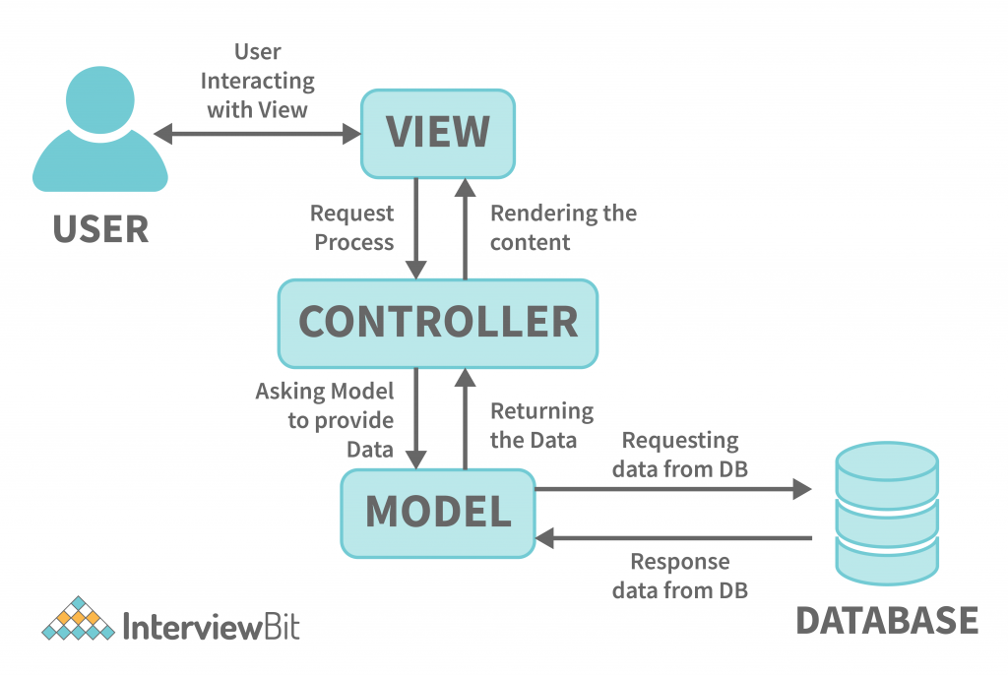
- User sends a request from the browser.
- Dispatcher Servlet receives the request.
- Dispatcher Servlet forwards the request to the appropriate Controller.
- Controller processes the request and interacts with the Model if needed.
- Model contains application data and business logic.
- Controller returns data and view information to Dispatcher Servlet.
- Dispatcher Servlet sends the response to the View.
- View displays the result to the user.
- This flow helps separate concerns and makes applications easier to maintain and scale.

